PCB Manufacturing Design Rules for Altium

** Document formatting needs an overhaul (this is not LaTex, sigh….) **

Introduction

This document describes design rules for Altium Designer that are being used for a variety of open-source project related to RFID, WISPs, and energy harvesting. The intent is to create a standard set of low tolerance design rules for Altium Designer that will allow a PCB to be manufactured at nearly any low cost fabrication house. We are basing these design rules on rules created by Sunstone Circuits www.sunstone.com the original document can be found here: http://www.sunstone.com/pcb-resources/Downloads.aspx

Details on Sunstone Circuits manufacturing capabilities can be found here:
http://www.sunstone.com/pcb-capabilities/manufacturing-capabilities.aspx

Final Sunstone Circuits’ Altium design rules are a little incomplete and at times confusing. Take special care to make drill sizes and annular ring sizes correct for manufacturing. See the section ‘Drill and Annular Ring Sizes” in this document for more Guidelines.

Basic design rules boil down to 6/6/16
- 6 mils minimum trace to trace clearance
- 6 mils minimum trace thickness
- 16 mils minimum hole size

- *8 mil minimum hole size is possible for 4 layers boards but is not advised for reliability reasons.

There are two versions of the Sunstone Circuits design rules for Altium, one for 2 layer PCBs and another for 4 layer PCBs. Make sure you are using the correct version for your project.

Version of Altium tested:
Altium Designer Summer 09

Revision History:
Creation: 5/11/2013
This document has maintained by Alanson Sample.

Sunstone Circuits’ design rules for Altium

 | Sunstone Circuits~Altium Design Rules
 | This set of Altium Designer Design Rules is the minimum requirements for Sunstone Circuits. When you begin designing your board these rules can be incorporated in order to stay in compliance with our manufacturing standards. You can load these rules when you begin to set up the PCB workplace in Altium Designer, after you have transferred your design from the schematic to the PCB and prior to positioning components on the board. You may find it necessary to create new rules along with our minimum standards to achieve desired results such as a clean DRC report.
 | We have created two sets of rules to help govern DFM requirements for Sunstone Circuits. The Altium~SSC-DFM_DS.RUL has been created to conform to rules for our Single & Double Sided circuit boards. The Altium~SSC-DFM_MLB.RUL has been created to help conform to rules for circuit boards designed with more than 2 layers. These settings are our minimum requirements; some values may be increased for your particular needs. Below is a list of the requirements included in this rule deck along with the default settings in Altium Designer 6.8
Sunstone Circuits |  | Altium Designer Default
Different Nets Only 6 mil | ELECTRICAL - Minimum Clearance | Different Nets Only 10 mil
Disabled (Not Allowed) | ELECTRICAL - Allow Short Circuit | Disabled (Not Allowed)
 | ROUTING
6 mils | Minimum Width | 10 mils
10 mils | Preferred Width | 10 mils
100 mils | Maximum Width | 10 mils
 | ROUTING VIA STYLE ~ Double Sided
30 mils | Via Diameter - Minimum | 50 mils
40 mils | Via Diameter - Maximum | 50 mils
30 mils | Via Diameter - Preferred | 50 mils
16 mils | Via Hole Size - Minimum | 28 mils
20 mils | Via Hole Size - Maximum | 28 mils
16 mils | Via Hole Size - Preferred | 28 mils
 | ROUTING VIA STYLE ~ Multi-layer
24 mils | Via Diameter - Minimum | 50 mils
40 mils | Via Diameter - Maximum | 50 mils
30 mils | Via Diameter - Preferred | 50 mils
8 mils | Via Hole Size - Minimum | 28 mils
20 mils | Via Hole Size - Maximum | 28 mils
16 mils | Via Hole Size - Preferred | 28 mils
 | MASK
3 mils | Solder Mask Expansion ~ Minimum | 4 mils
 | PLANE – Power Plane Connect Style
Relief Connect | Connect Style | Relief Connect
4 | Conductors | 4
8 mils | Conductor Width | 10 mils
10 mils | Air Gap | 10 mils
10 mils | Expansion | 20 mils
 | PLANE – Power Plane Clearance
12 mils | Clearance | 20 mils
 | PLANE – Polygon Connect Style
Relief | Connect Style | Relief
4 | Conductors | 4
90° | Angle | 90°
8 mils | Conductor Width | 10 mils
 | MANUFACTURING
7 mils | Minimum Annular Ring | 10 mils
Absolute | Hole Size Constraint - Measurement Method | Absolute
16 mils | Hole Size Constraint – Minimum (DS) | 1 mil
8mils | Hole Size Constraint – Minimum (MLB) | 1 mil
251 mils | Hole Size Constraint – Maximum (DS) | 100 mil
251 mils | Hole Size Constraint – Maximum (MLB) | 100 mil
 | HIGH SPEED
Disabled | Allow Vias Under SMD | Disabled

Drill and Annular Ring Sizes

Sunstone uses a preset number of drill sizes. If you happen to choose a non-standard drill size for a via or hole, Sunstone will round up to the next largest drill bit size. This can cause problems if your annular is not large enough to support the larger hole size and you may not pass Sunstone’s automatic DRC checking tool.

See the following link for a list of drill sizes:
http://www.sunstone.com/products-services/quickturn-proto-boards/drill-file-pad-clearance-setup.aspx

The images below shows drill size and annular ring (larger sizes a possible of course, see link). I highly suggest setting creating a set of predefine vias on the side of your PCB document that you can quickly copy and paste when you are design your project.

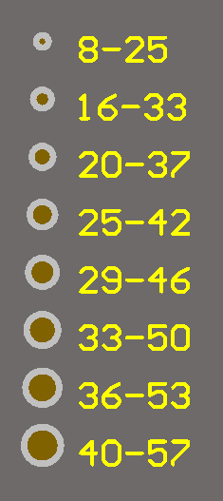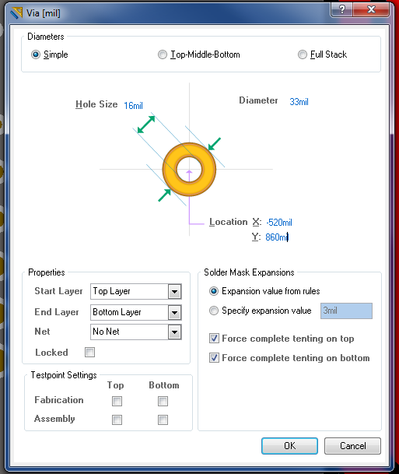

Import Sunstone Circuits DFM RUL

To import Sunstone Circuits DFM RUL, go to Design » Rules…

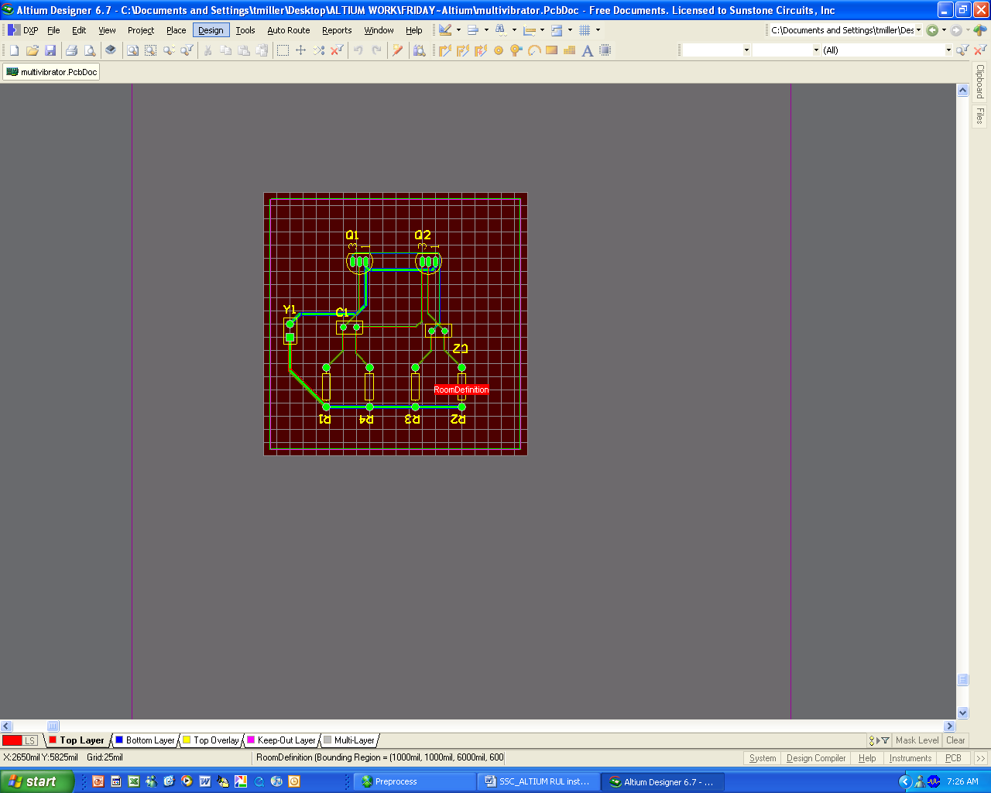

And the PCB Rules and Constraints Editor Window will open. To import the Altium~SSC-DRC_DS-Beta1.1.RUL (or Altium~SSC-DRC_MLB-Beta1.1.RUL), right click anywhere within the folder-tree pane on the left hand side of the PCB Rules and Constraints Editor Window and choose Import Rules… from the pop-up menu.

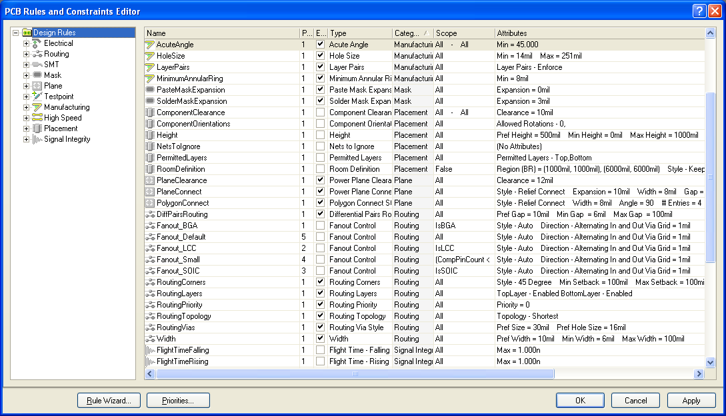

The Choose Design Rule Type dialog will appear. Select the type(s) of design rules you wish to import and click OK. Since our rule decks consists only of rules specifically related to our DFM requirements at Sunstone Circuits, you may select all rules here to be imported. Click in the dialog and use Ctrl+A to select all of the listed design rules then press OK. The only rules that will be overwritten will be the ones that our rule deck consists of and the remainder will contain the original settings.

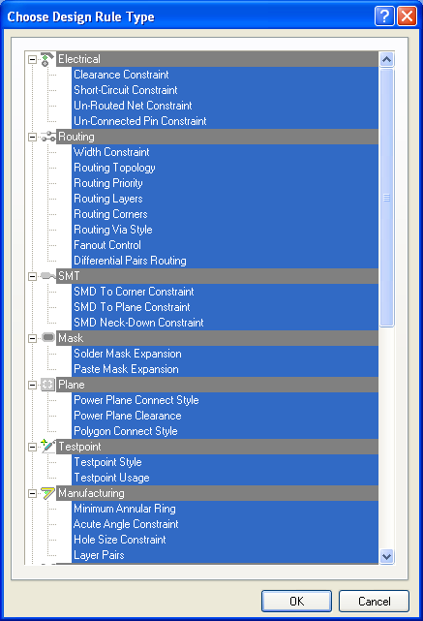

The Import File dialog will appear, browse to your desired folder and open the PCB Rule file that you wish to import. If those rules already exist, even by default, you will be asked if you wish to clear existing rules prior to import. Choose yes to replace and update with the Sunstone Circuits DFM rules.

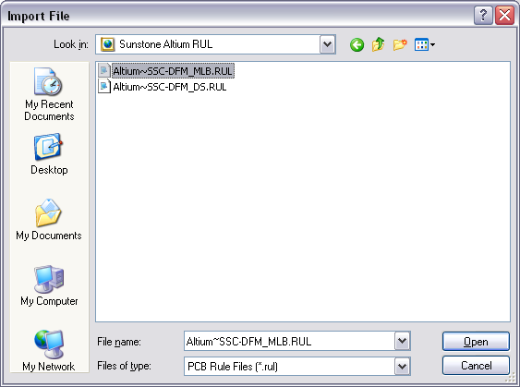

Additional design Rule modifications:
*a work in progress
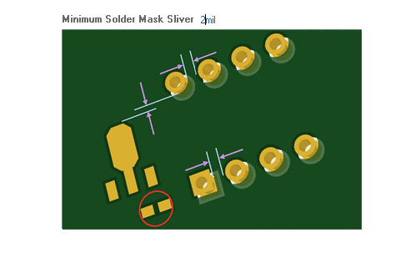
Minimum Solder Mask Sliver now 2mi (orignally 10mils)

Silkscreen errors disabled (SilkscreenOverComponentPads & SilkToSilkClearance)
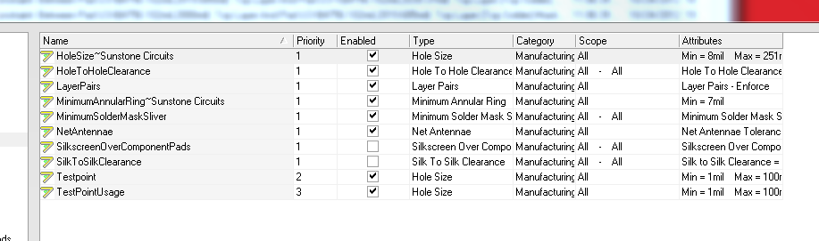
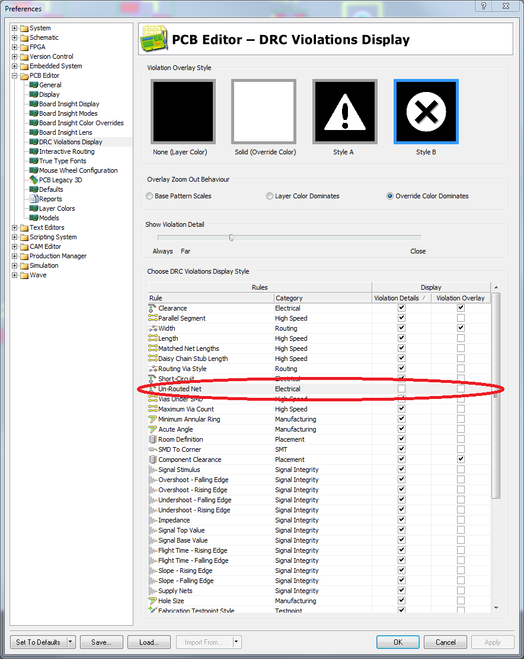

Altium Tips and Tricks

Convert special strings
Issue: mechanical layers do not show special strings properly. Footprints show “.designator” on mechanical 13 and 14 instead of the actual designator name.

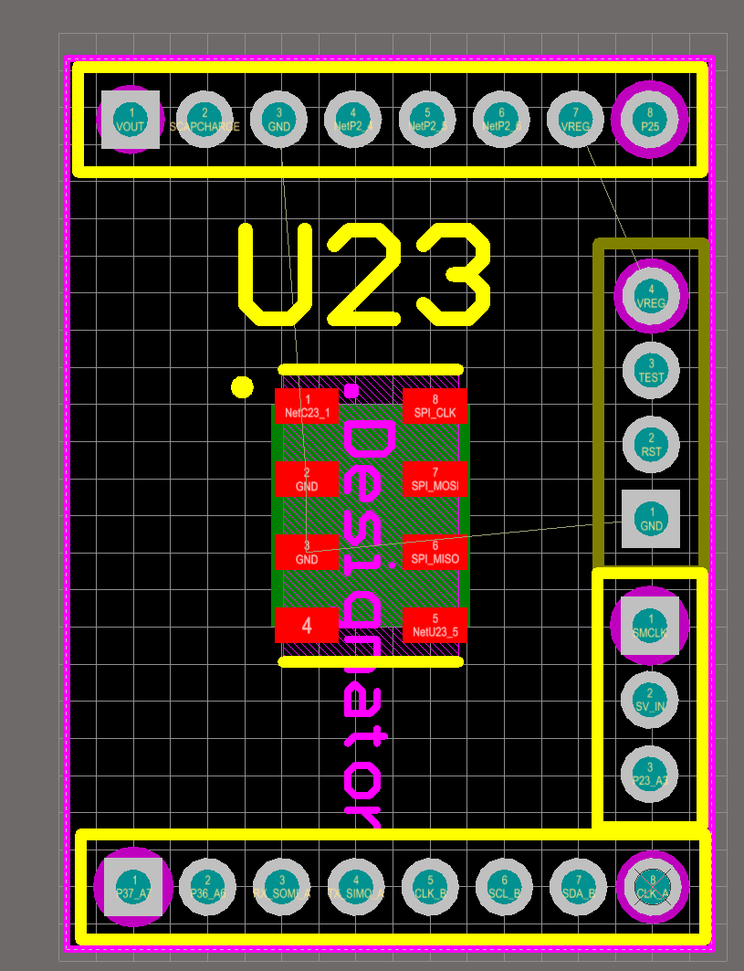

Hot Keys “o → l” (use lower case “O → L”)
Select the “Veiw Options” tab
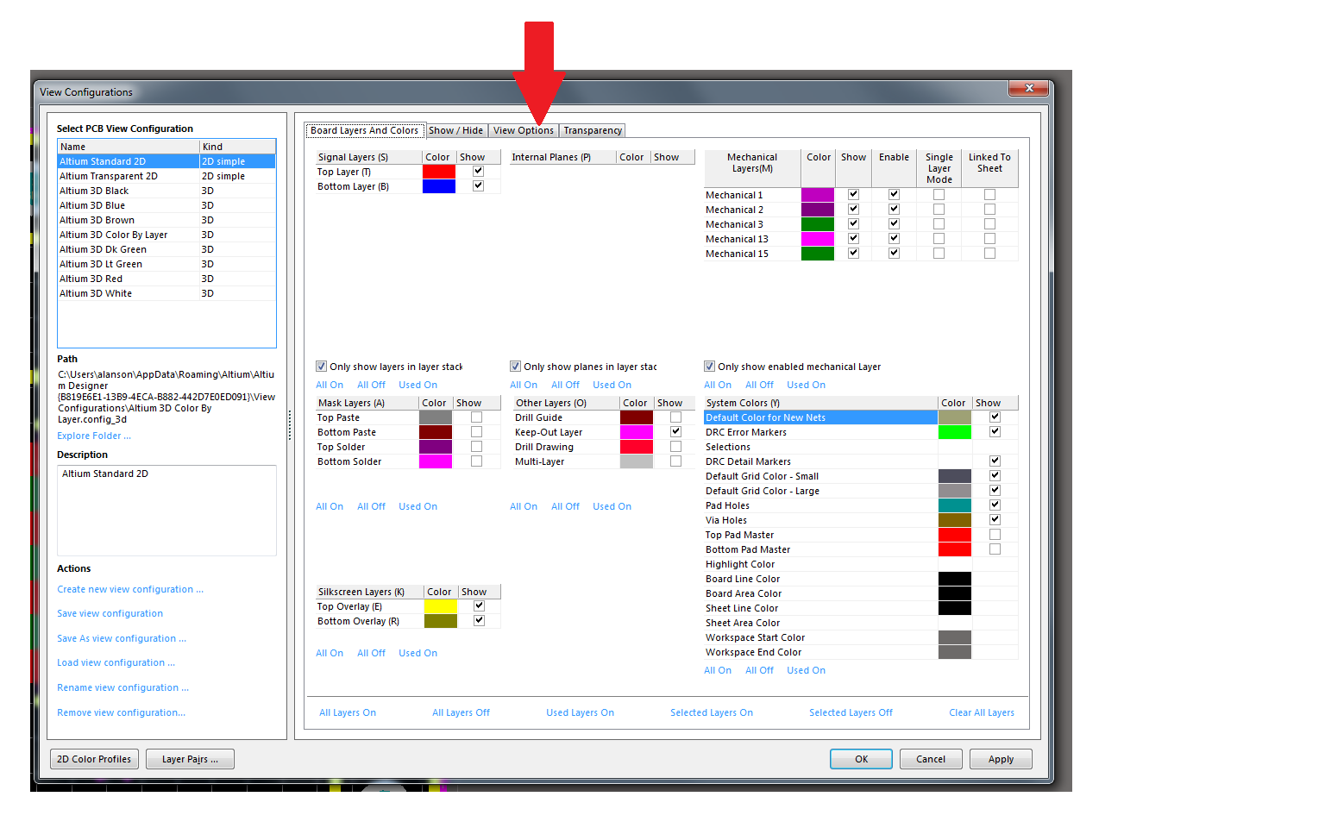

Check the box for “convert special strings”
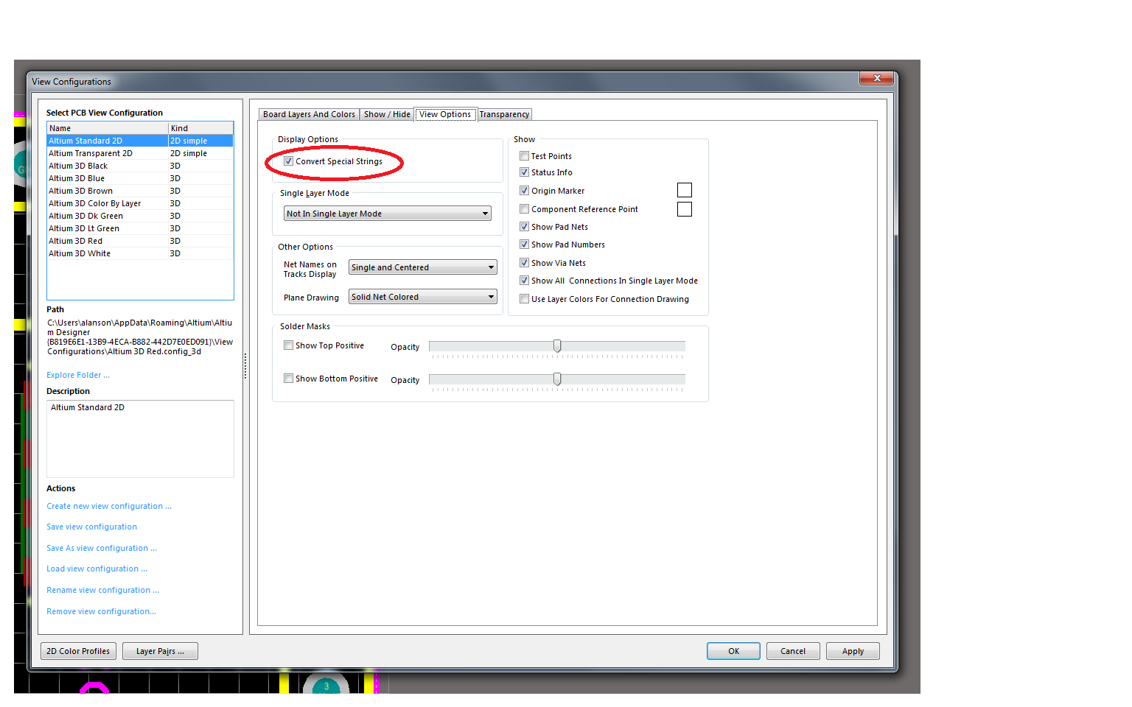

Now “.designator” is converted to “U23”.

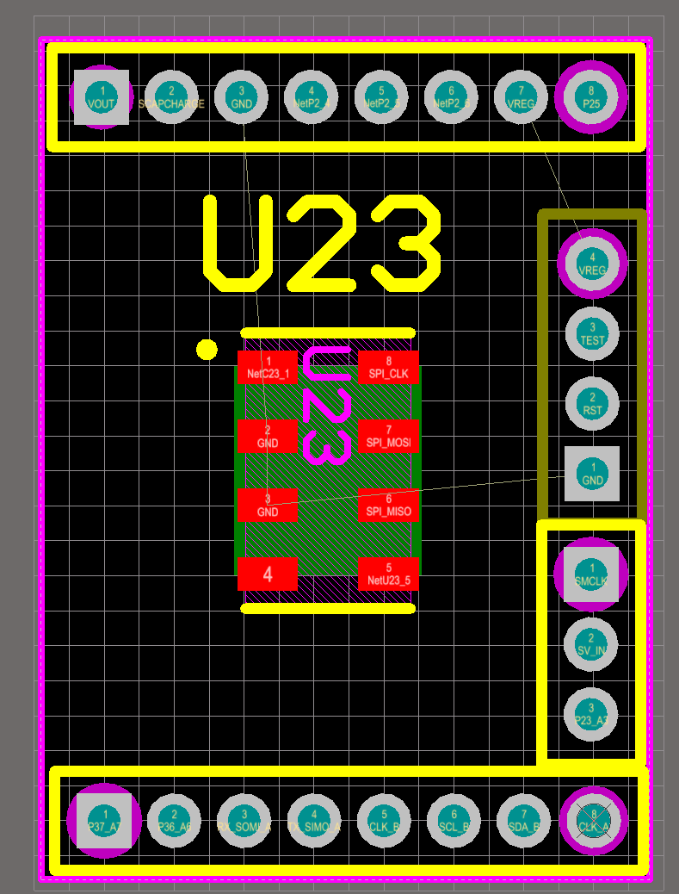

Setting layer pairs

Mechanical layers can be paired. Used this feature when you need extra detail in the component footprint, and that detail needs to change to another layer when the component is moved from the top side of the board to the bottom side. An example of this is glue dot information.

- Configure Mechanical pairs by clicking the Layer pairs button at the bottom of the View Configurations dialog, or right clicking on the layer tabs and selecting Configure Mechanical Pairs.
- The objects placed on a mechanical layer in the PCB library will flip to its paired layer when the component is switched to the bottom of the board.
- Click the Add, Delete or Mechanical Pair Properties buttons in the Mechanical Layer Pairs dialog to modify the mechanical layer pairs.

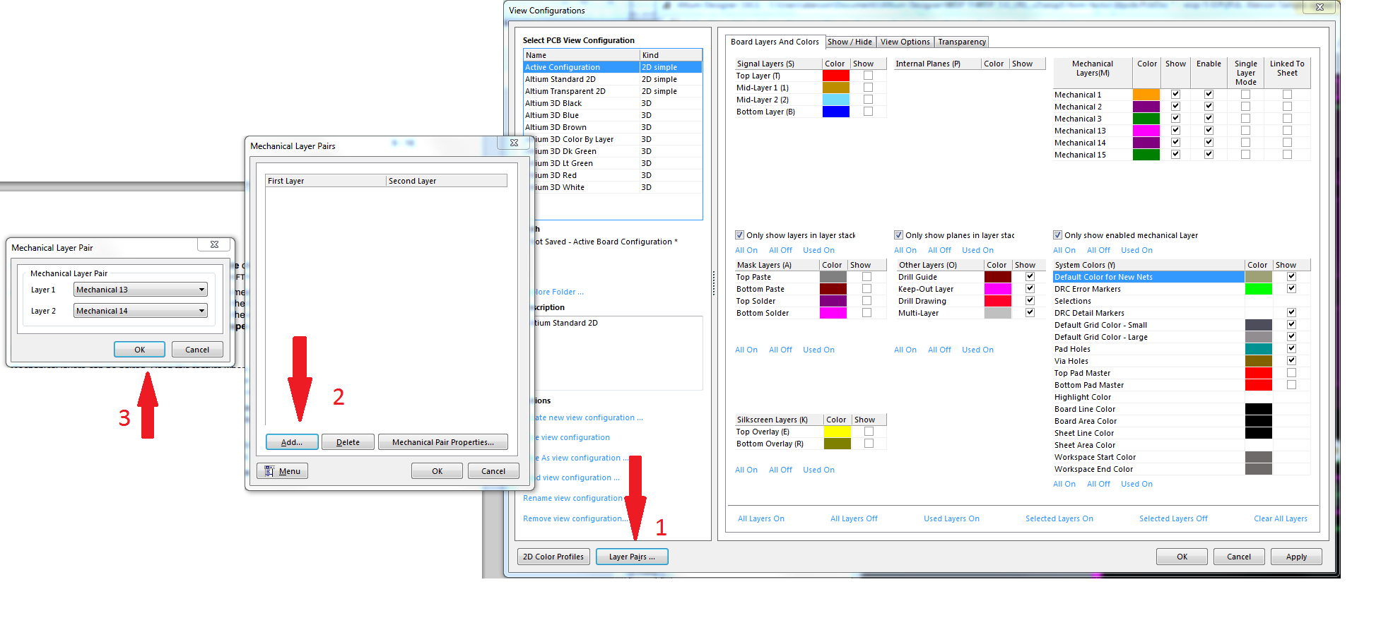

Gerber Files Mapping for Sunstone

File Name | Windows “Type” Description | Actual Meaning | Sunstone
SeriesTunning_v1.apr | CAMtastic Aperture Data (.apr) | Used to define some types of holes and cut outs
SeriesTunning_v1.GLO | CAMtastic Top Overlay Gerber Data (.GLO) | Top silkscreen | Top Silkscreen layer:
SeriesTunning_v1.GTS | CAMtastic Top Solder Mask Gerber Data (.GTS) | Top solder mask (green coating on PCB) | Top Solder Mask layer:
SeriesTunning_v1.GTL | CAMtastic Top Layer Gerber Data (.GTL) | Top metal layer | Top Copper layer:
SeriesTunning_v1.GBL | CAMtastic Bottom Layer Gerber Data (.GBL) | Bottom metal layer | Bottom Copper layer:
SeriesTunning_v1.GBS | CAMtastic Bottom Solder Mask Gerber Data (.GBS) | Bottom solder mask (green coating on PCB) | Bottom Soldermask layer:
SeriesTunning_v1.GBO | CAMtastic Bottom Overlay Gerber Data (.GBO) | Bottom silkscreen
SeriesTunning_v1.GKO | CAMtastic Keepout Layer Gerber Data (.GKO) | Board outline | Board Outline:
SeriesTunning_v1.DRR | Altium NC Drill Report File (.DRR) | Drill report  - detailing the tool assignments, hole sizes, hole count and tool travel | Tool Size Report:
SeriesTunning_v1.TXT | Text Document | ASCII format drill file. Again, for a multi-layer PCB that incorporates blind and/or buried vias, a separate drill file for each layer pair is created, with a unique file extension | Plated Holes:  Excellon Format Drill File
Status Report.Txt | Text Document
FileName.DRL |  | Binary format drill file. For a multi-layer PCB that incorporates blind and/or buried vias, a separate drill file for each layer pair is created, with a unique file extension

Library development guidelines

Schematic Libraries
(xyz.schlib)

All symbols should have the following parameters fields:
8 fields in total

Digi-Key Part Number | *
Distributor | *
Distributor Part Number | *
Manufacture | *
Manufacture Part Number | *
Note | *
Rating | *
Value | *

It is possible to edit all the add / remove and modify all the parameters in a schematic library globally using Tools >> Parameter manager

Footprint Libraries
(xyz.pcblib)

All footprint should use the following layers in the following ways:

Draft / suggestions
M1 – Titleblock
M2 – Board Outline (why that is or the keep out layer is for)
M3 – Board Reference

M? – Land marks, centers, coordinate system marks
M? – User notes
M? – Manufacture notes
M? – Keep out layer for parts?

Should 3d bodies be on a separate mechanical layer then assembly?

Mechanical 13 | Assembly Drawings | .designator string, 3D body extrusion, pin 1 marker (if applicable)
Mechanical 14 | Reserved as layer pair for Mechanical 13
Mechanical 15 | Courtyard & Centroid
Mechanical 16 | Reserved as layer pair for Mechanical 15

-------------
https://groups.google.com/forum/#!topic/SanDiegoAltiumUsersGroup/6h6KntQj5io

IPC Library Preset Single Board Preset
M13 – Assembly Top M1 – Titleblock
M14 – Assembly Bottom M2 – Board Outline
M15 – Courtyard Top M3 – Board Reference
M16 – Courtyard Bottom

---------------------
http://cladlab.com/electronics/general/altium/altium-tricks-and-standards

Layer | Usage
Mechanical 1 (M1) | Board outline (it is not recommended to use just the keep-out layer, since that can be used for other things also).
Mechanical 2 (M2) | PCB info (manufacturing info, added as text).
Mechanical 11 (M11) | Top layer dimensions (paired with M12).
Mechanical 12 (M12) | Bottom layer dimensions (paired with M11).
Mechanical 13 (M13) | Top layer component body information (3D models and mechanical outlines, paired with M14).
Mechanical 14 (M14) | Bottom layer component body information (3D models and mechanical outlines, paired with M13).
Mechanical 15 (M15) | Top layer courtyard and assembly information (paired with M16).
Mechanical 16 (M16) | Bottom layer courtyard and assembly information (paired with M15).

